FIELD CATALOG INTRODUCTION
Contents
1. What Field Catalog is 2
2. Who end-user(s) are 2
3. Why is Field Catalog 2
4. How to use 3
a. Log-in 3
b. Main screen 4
c. New Product 5
d. Manage product 7
e. New Screen 8
f. Manage Screen 10
g. New Field 11
h. Manage Fields 12
i. Screen Image 13
j. Product/Screen Map 15
k. Screen/Field navigation map 16

What Field Catalog is
This is a centralize system to
- Define Software Products
- Define Software Products Version
- Define Screens
- Define Rules
- Build Relationships between Products, Versions, Screens and Fields

Beside core features, the system will provide more functions for end-user(s) such as
- Search
- Tag
- Control by Role
- Control by Group
- Comparison with Version or Versioning

Who end-user(s) are
The targets for this product are persons who are working in IT department(s) such as
- Developers
- Quality Controls
- Business Analyst
- And More ..

Why is Field Catalog
As a person who is evolving to software development and maintenance, we always have below questions:
- What are business rule relating to this screen?
- What are business rule relating to this field?
- If we change this field on this screen, what are impacted area we need to take care of?
- If we change a message M6478 in the system, how many flows and fields or screens we have to perform testing and impact analysis?
- And more …
To answer or solve those problems or questions, Field Catalog was born

How to use

Log-in
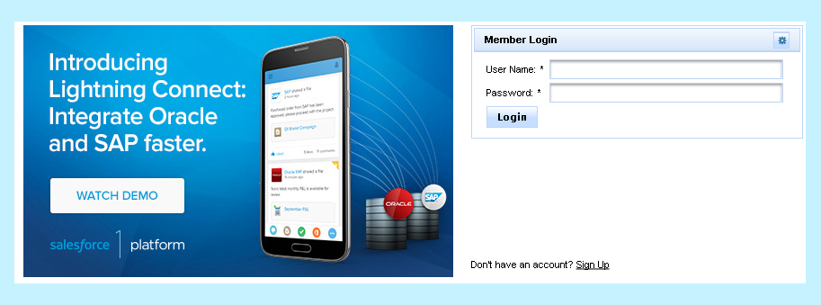
Please enter your login information to sign in. Base on your log-in, the system will see if your role is. And screens, menu will be displayed accordingly with your role.

Main screen
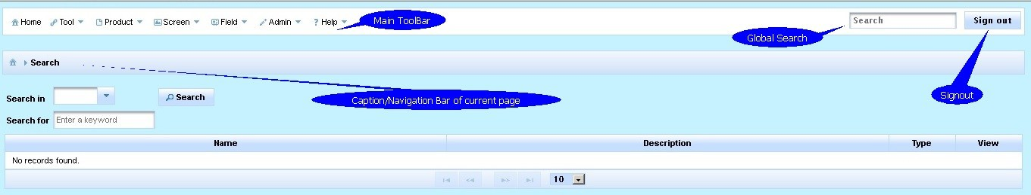
The main screen contains
- Main toolbar
This is always on top for all pages in Field Catalog and controlled by log-in role.
- Global Search
This is a search for everything in Field Catalog. Anything you need, you just type in Search text box and Enter.
- Sign out button
This is to log you out of the application
- Working area
This varies depend of page you are on. As you see in Main screen, the working area will be Search.

New Product
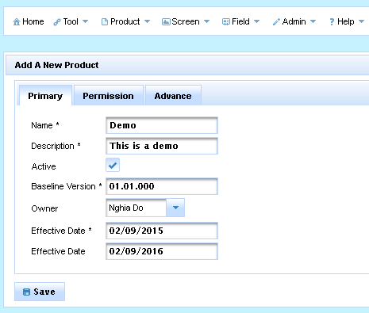

To create a Product, there are 4 categories of information, you can set it up
- Primary
  - Name
  - Description
  - Active
  - Baseline Version
  - Owner
  - Effective Date
  - Expiration Date
- Permission
This is to grant View/Design permission for groups.
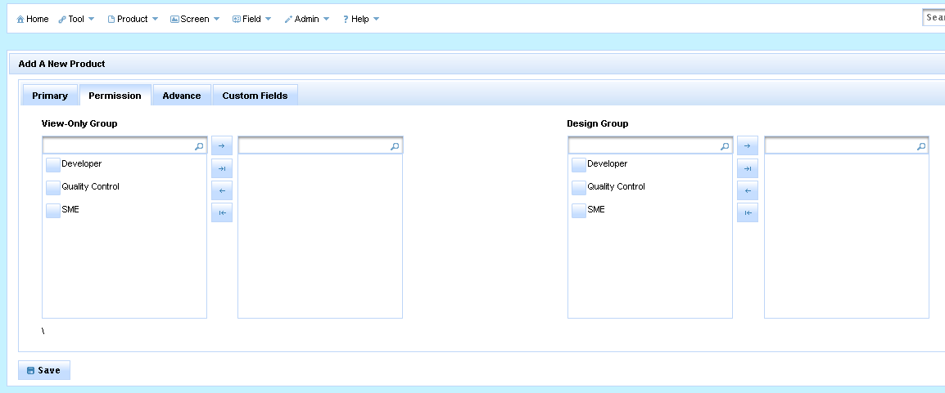
- Advance
This is to help you tag Keyword(s) to the product
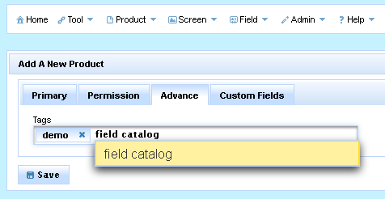
- Custom Fields
This is to a very strong featuring which to allow you to create dynamic information which is customized for your products. Please see how the system create and generate Custom Fields in Custom Field section.
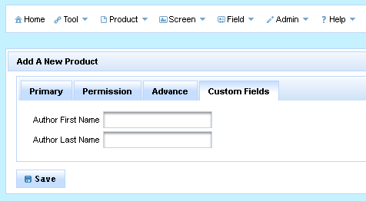

Manage product
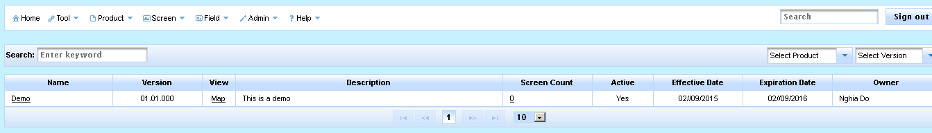
This page is to list all products in the system as well as features such as Search and Filter. From this page you can go to
- Detail Product page: This is allow to view/edit detail of Product page
- Product Map: This is to see all screens/fields belong to the Product as graphic mode
- Screen List page: This is to see all screens belong to this Product

New Screen
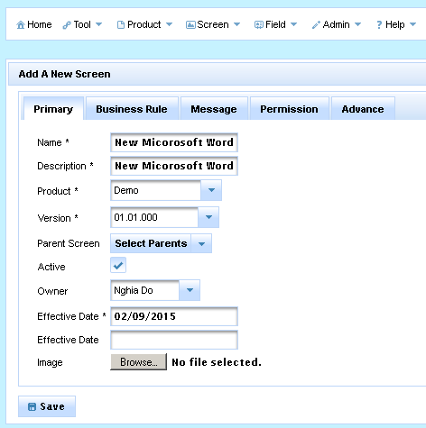
To create a Screen, there are 5 categories of information (actually 7, I will mention 2 more later), you can set it up
- Primary
  - Name
  - Description
  - Product
  - Product Version
  - Parent Screen
Note: To define relationship between this screen and parent screens if it has.
  - Active
  - Owner
  - Effective Date
  - Expiration Date
  - Image
Note: This is a screen-shot of this screen so later than we can define fields on this screen-shot
- Business Rule
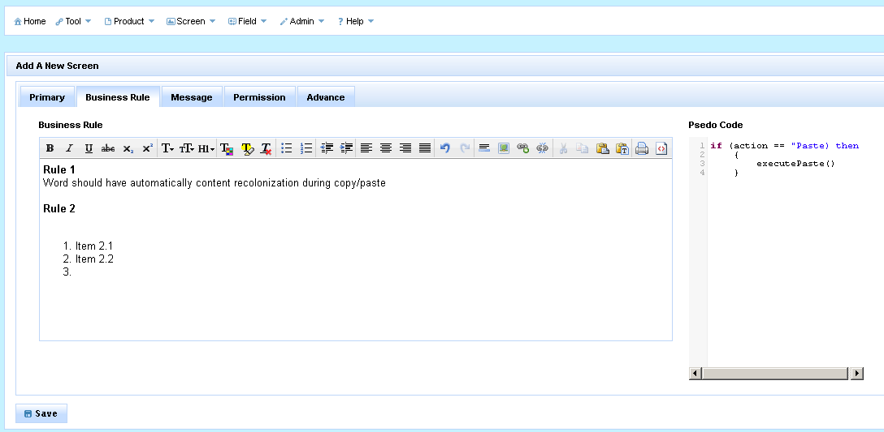
This is to capture business rules or Pseudo code which relates to this screen. Search function can search on those fields.
- Message
This is to link all messages to this screen. For an example, if you are creating a Screen name “Login”, and in case, the user enters wrong username/password, the system fires a message “E7612 UserName/Password is not correct”, so you will create a link between Login screen and the message E7612.
- Permission
This is the same as Permission of Product. This is to grant View/Design permission for groups.
- Advance
This is the same as Advance of Product. This is to tag Keyword.

Manage Screen
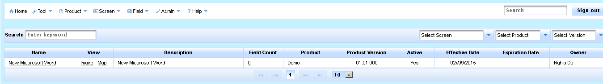
This page is to list all screens in the system as well as features such as Search and Filter. From this page you can go to
- Detail Screen page: This is allow to view/edit detail of Screen page
- Screen Image: This is a page which you can view/define fields for this screen base on screen-shot. Using Tagging feature.
- Screen Map: This is to see all child screens/fields belong to the Screen as graphic mode
- Field List page: This is to see all fields belong to this Product

New Field
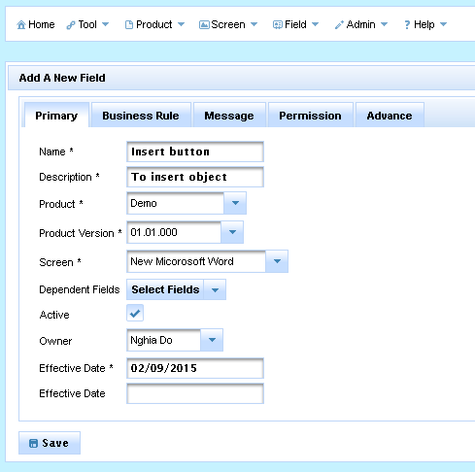
To create a Field, there are 5 categories of information (actually 7, I will mention about 2 more later), you can set it up
- Primary
  - Name
  - Description
  - Product
  - Product Version
  - Screen
  - Dependent Fields
Note: To define relationship between this fields and other fields if it has.
  - Active
  - Owner
  - Effective Date
  - Expiration Date
- Business Rule
This is the same as Business Rule of Screen. This is to capture business rules or Pseudo code which relates to this field.
- Message
This is the same as Message of Screen. This is to link all messages to this field.
- Permission
This is the same as Permission of Product. This is to grant View/Design permission for groups.
- Advance
This is the same as Advance of Product. This is to tag Keyword.

Manage Fields
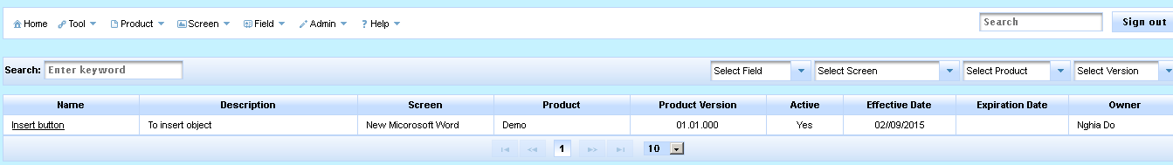
This page is to list all fields in the system as well as features such as Search and Filter. From this page you can go to
- Detail Field page: This is allow to view/edit detail of Screen page

Screen Image
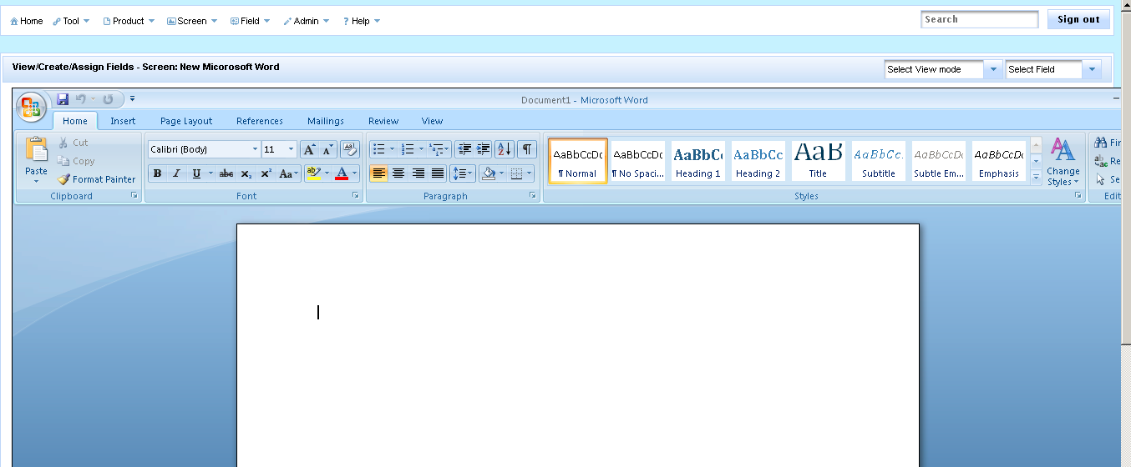
This page is to create Fields base on screen-shot of a Screen. You can go to this page by using Screen > Manage > Image.
On this page, you can Right Click 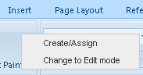 to open a context menu which you can Create/Assign field on a screen.
- Create/Assign
If you select Create/Assign, the system will change mouse cursor and allow you to drag a rectangle to define an area of a field as below
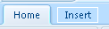
After we define a rectangle and release mouse, the system will promote you a dialog with options
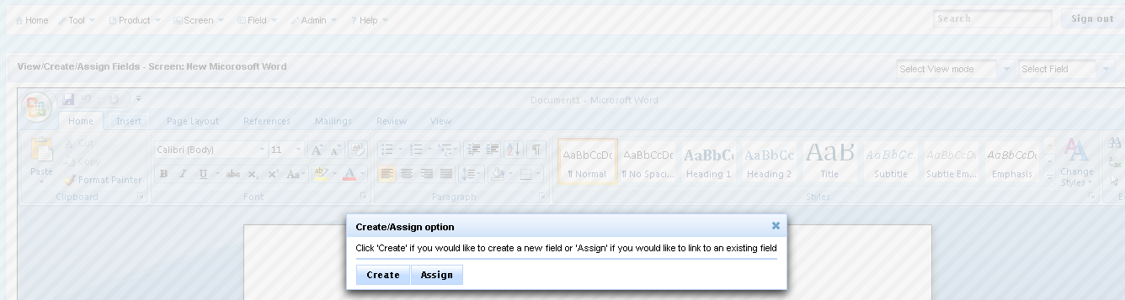
  - If you pick Create, then the system allows you to create a new Field with minimum information
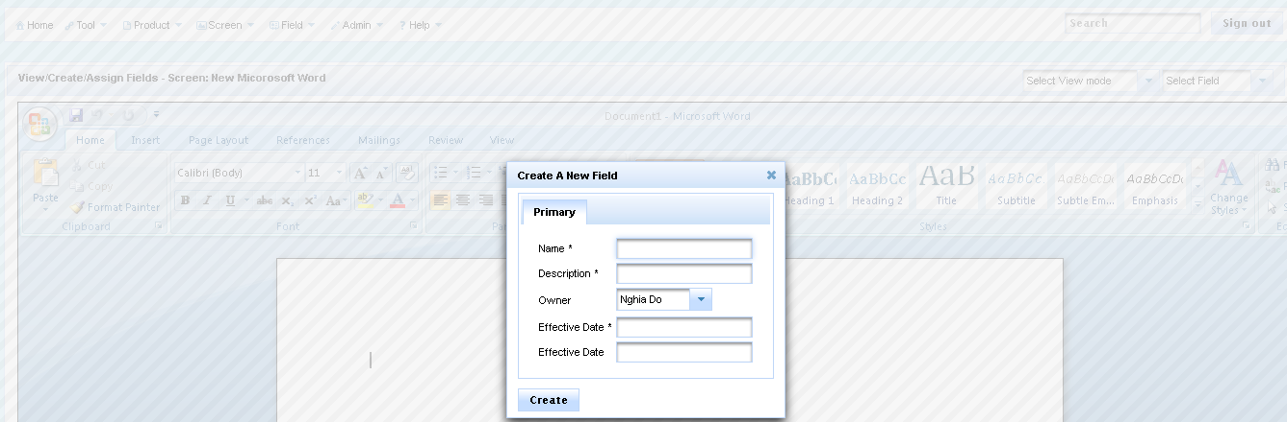
  - If you pick Assign, then the system allows you to link an existing Field
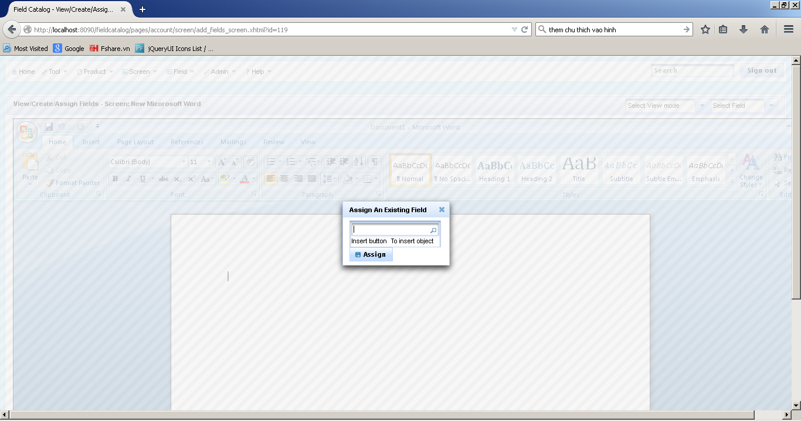

After you Create/Assign, you will see something as below
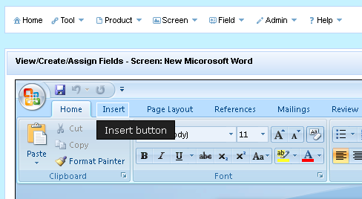
It does mean a Field linked to Screen already. You can click on that rectangle to go to Field detail page to view information about that field.

Product/Screen Map
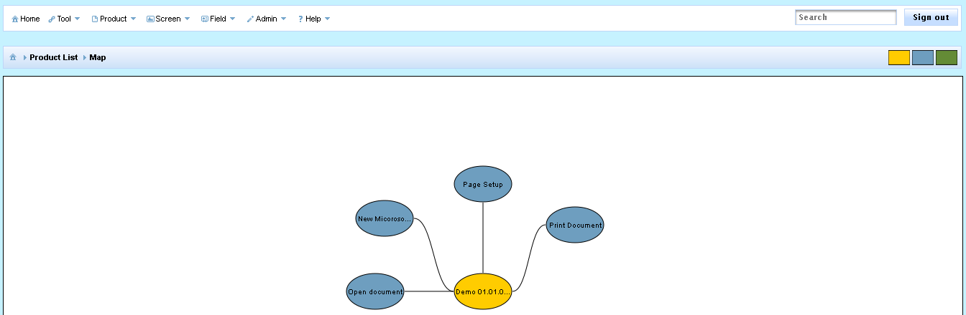
This page is to show you all Screens/Fields belong to the selected product. As below screen, the product has 4 screens New Document, Open Document, Print Document and Page Setup.
You can come to this page by
- Product > Product Manage > Map
- Screen > Screen Manage > Map
If you want to go deeper such as to see how many child screens or how many fields on a screen, you simply click on that screen, you can see one more level deeper. For example, I want to see more about New Document screen, I click on it and see, ‘New Document’ screen has ‘Insert Button’ field.
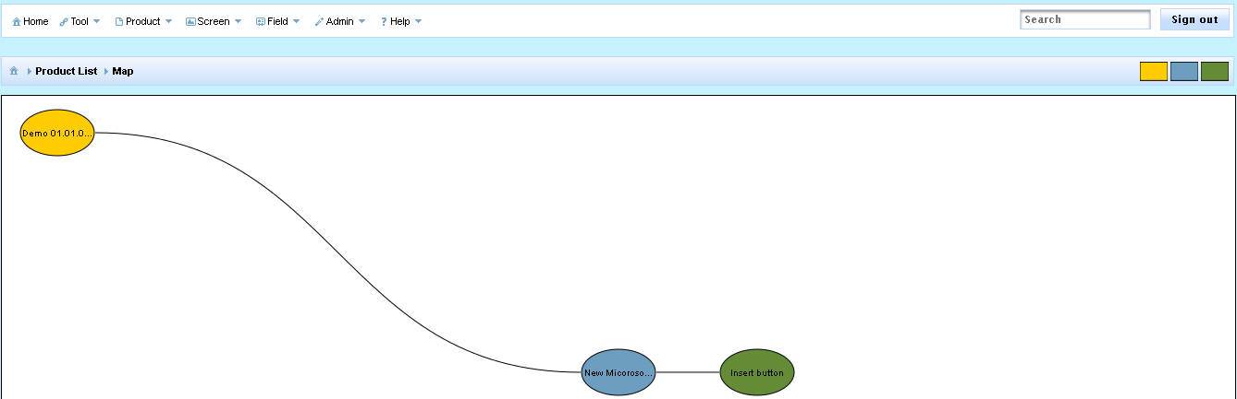

Screen/Field navigation map
As I mentioned above in New Screen section, we can define one more many parents for a screen. For example we can have this case in Microsoft Word as on Main screen, click Open and then the Open dialog displays, it means in Open Dialog screen has ‘Main’ screen as a parent. For that instance, we can define as below
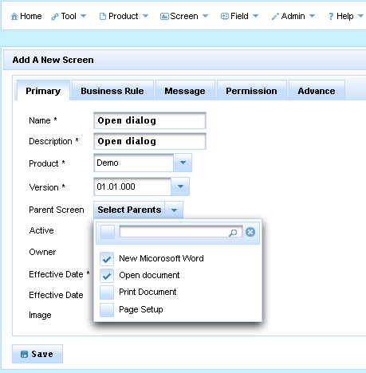
Later than, if you want to see Navigation Map for ‘Open Dialog’ screen, you can see as below
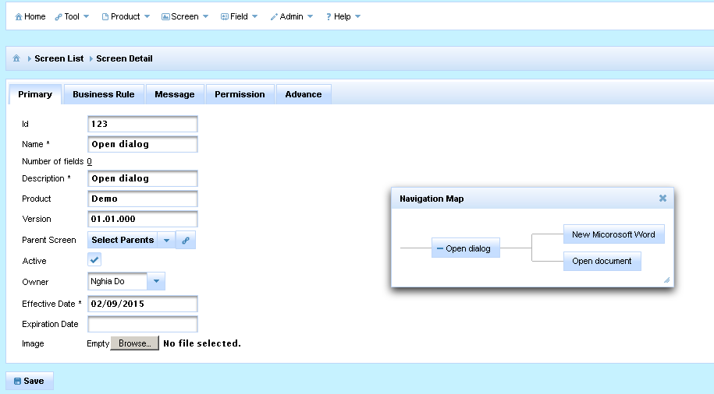
As you can see, the system will show Open dialog has 2 parents. It does help us in term of answering If I change code/business rules for ‘Open Dialog’ , we need to cover 2 flows from ‘New Microsoft Word’ and ‘Open Document ‘

New/Manage User
This is to New/Manage users in Field Catalog. I will not document much here because it is very common in every system.

New/Manage Group
This is to New/Manage groups in Field Catalog. I will not document much here because it is very common in every system.

New/Manage Events
Well, let think like, you want to document what your system behaviors when a screen is load or unload. Or you want to document what your system does when a button is clicked. You can say, you can enter those things for Business Rule tab when you create Screen or Field. That is correct too.
But it is better if somehow we can link rules specific to Load event or Click event. That is why I provide Events in Field Catalog.
Take one example, if I want to support Click event for Fields. I will define a Click event using New Event screen
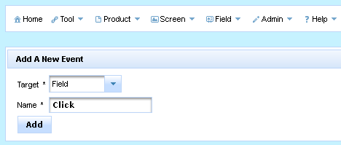
After that, you can see the system will generate for you more space to enter Rules for Click event on every field. Now we can see Event tab when you create/edit Field.
The same thing will apply for Screen too.
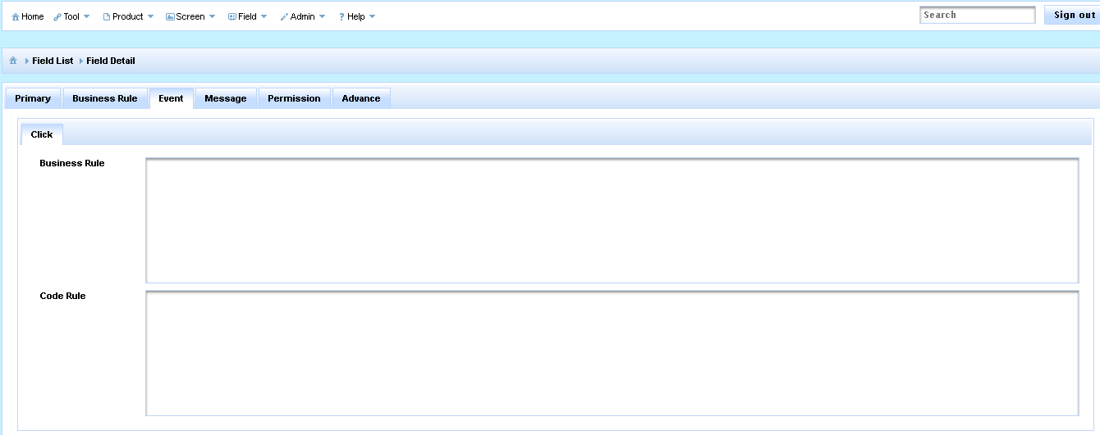

New/Manage Custom Fields
When you create Product/Field or Screen, currently the system allows you capture information such as Name/Description/Effective Date …But you want to capture more fields so How.
That is why I provide Custom Fields in Field Catalog.
Take one example, if I want to support 1 more piece of information I want to capture during create a Screen name ‘Developer Note’.
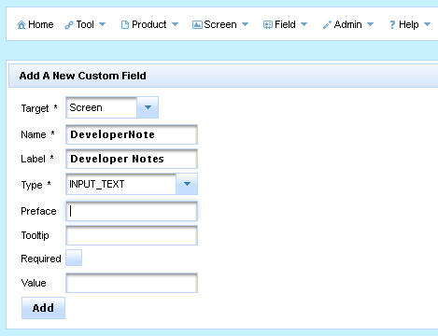
After that, you can see the system will generate for you 1 text box to enter ‘Developer Note’ on every Screen. Now we can see Custom Field tab when you create/edit Screen.
The same thing will apply for Product/Field too.
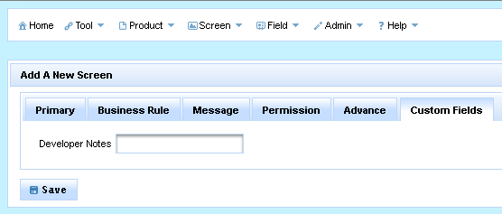
Currently, Custom Fields support below control types
